1. Create VPC with 2 private and 2 public subnets.

VPC

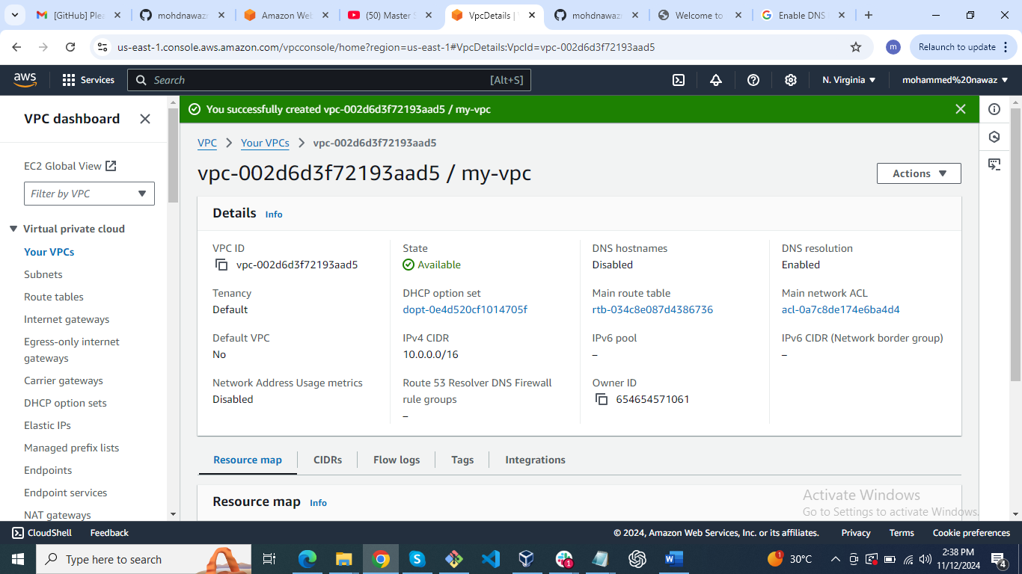

Private subnet 1

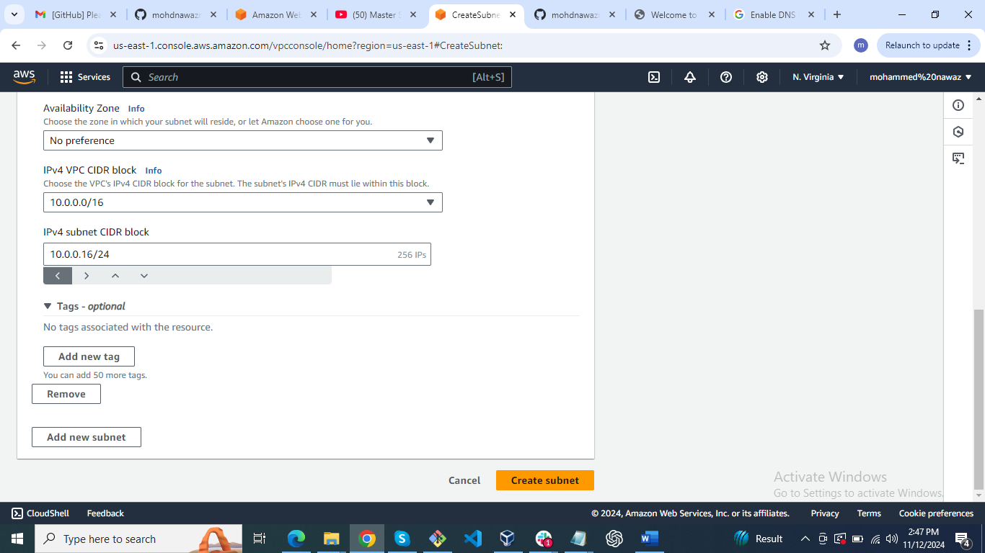

Private subnet 2

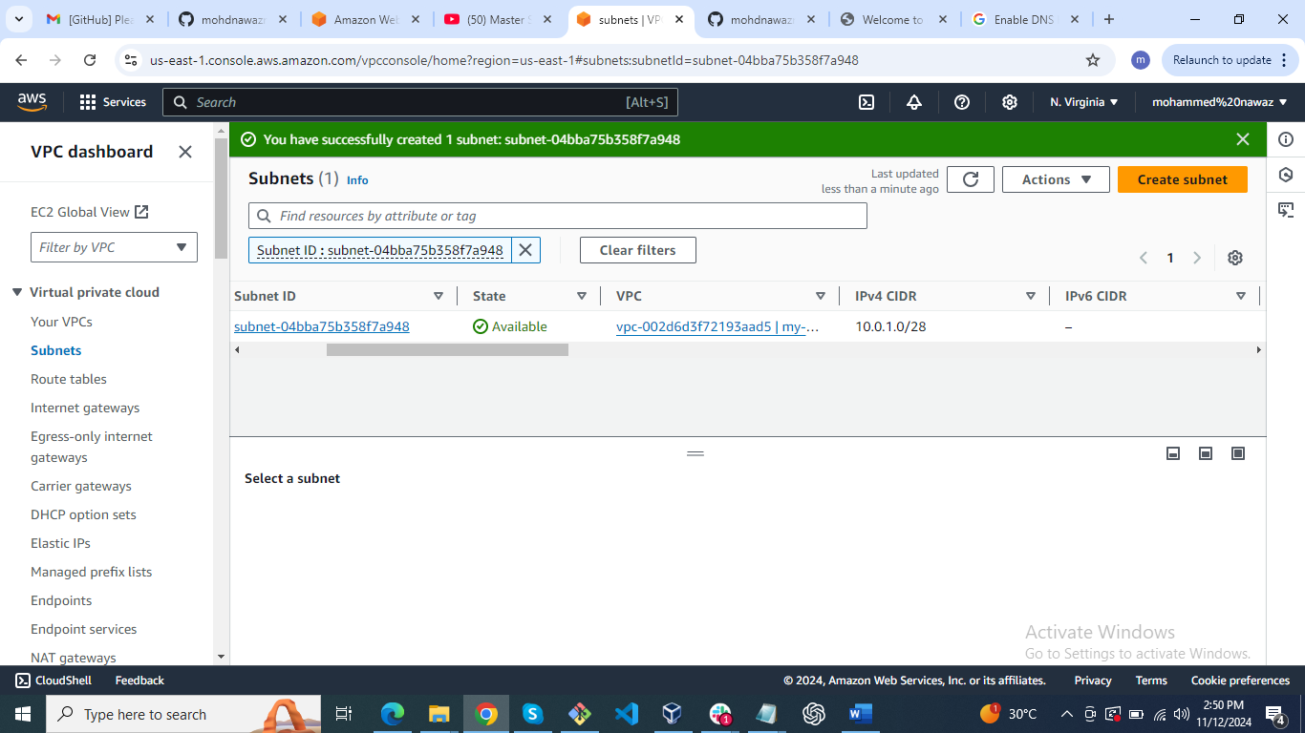

Public subnet 1

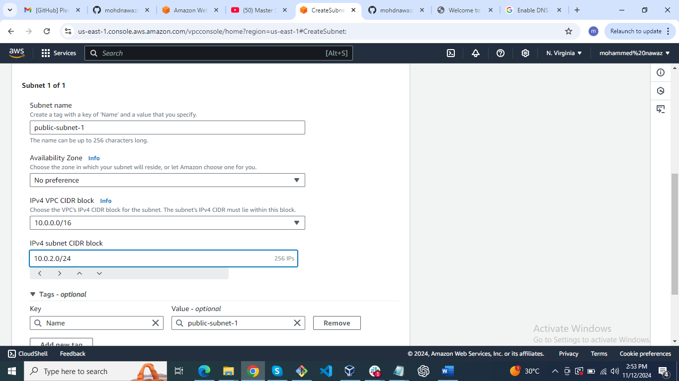

Public subnet 2

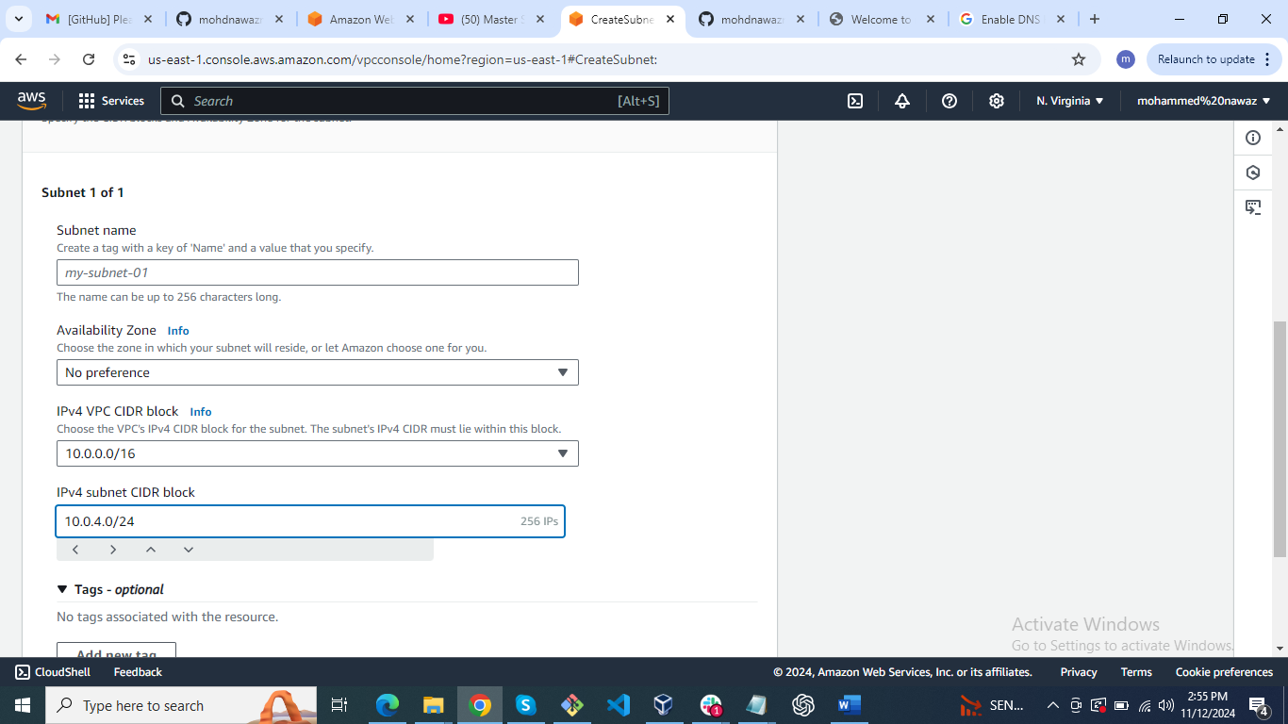

1. Enable DNS Hostname in VPC

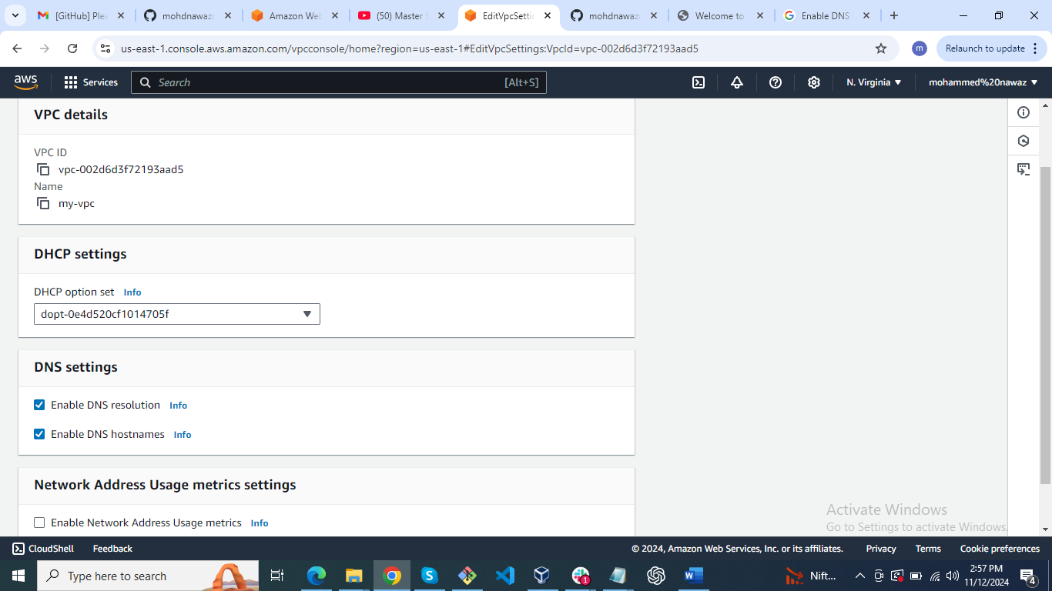

3) Enable Auto Assign Public ip in 2 public subnets

Public subnet-1 settings

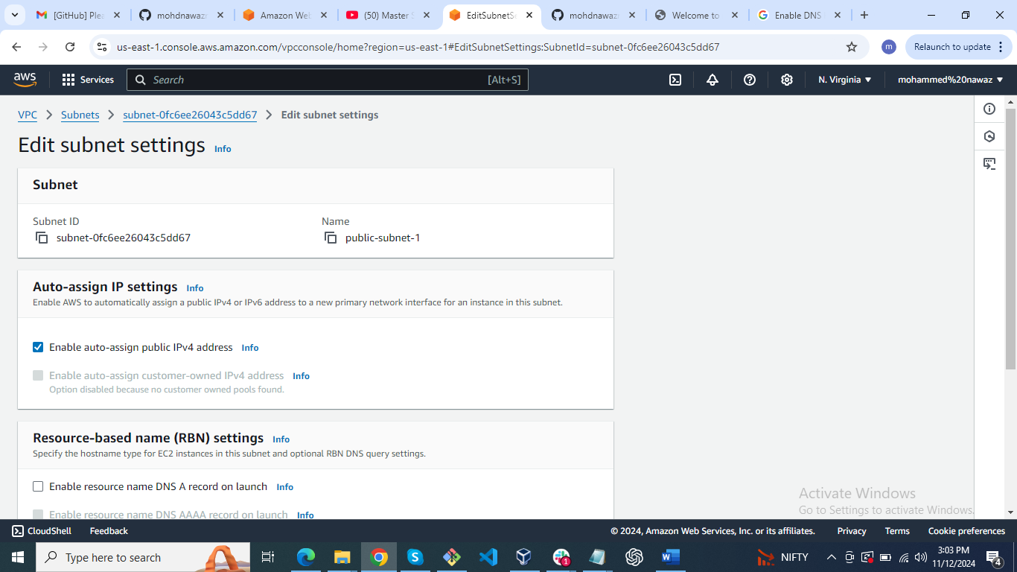

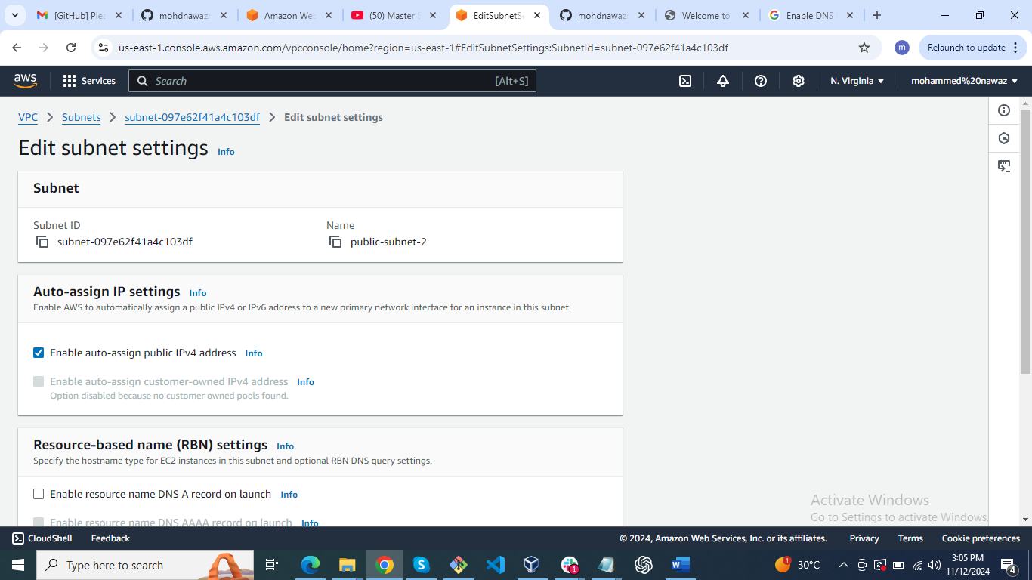

1. Add 2 private subnets in private route table

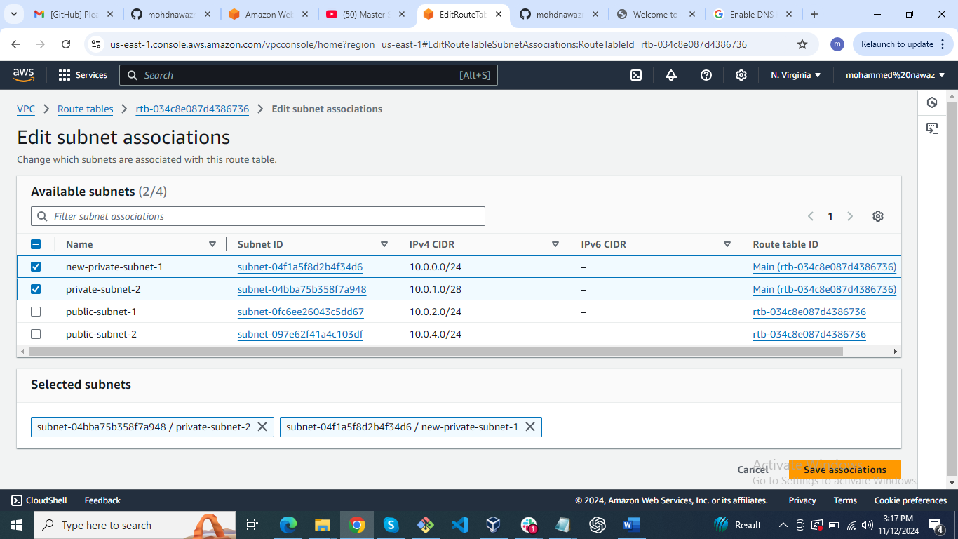

1. Add 2 public subnets in public route table

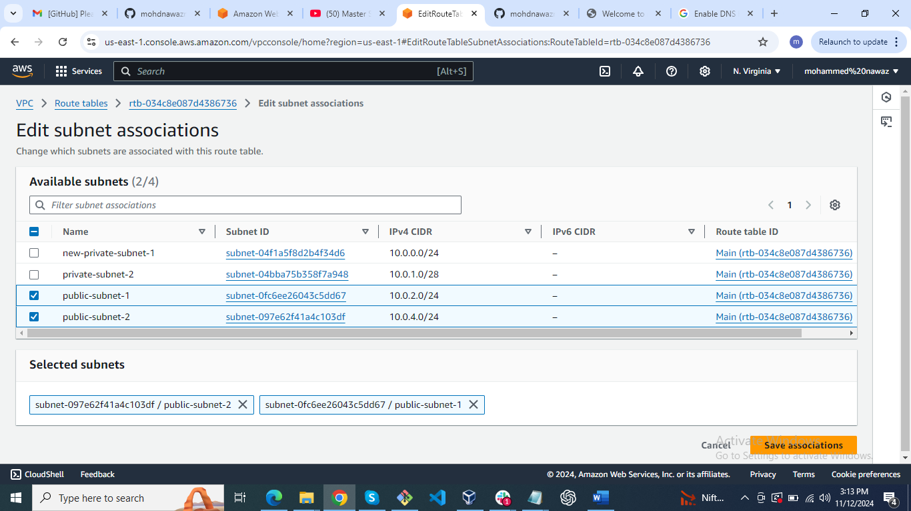

1. Public route table will have the routes to internet and local

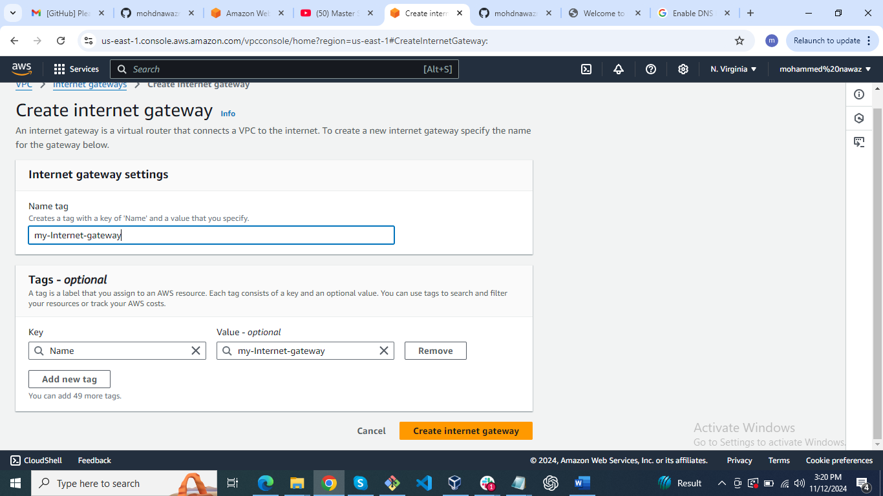

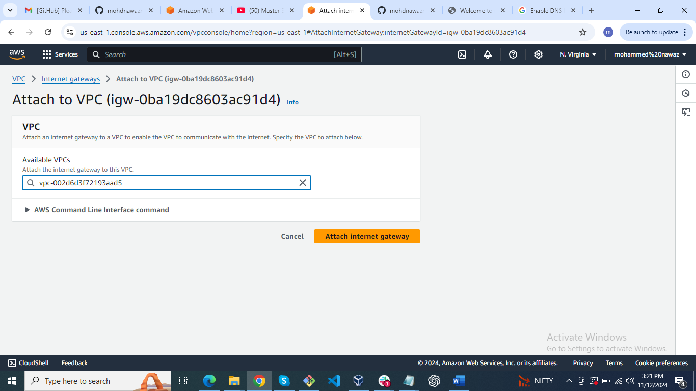

Internet and local

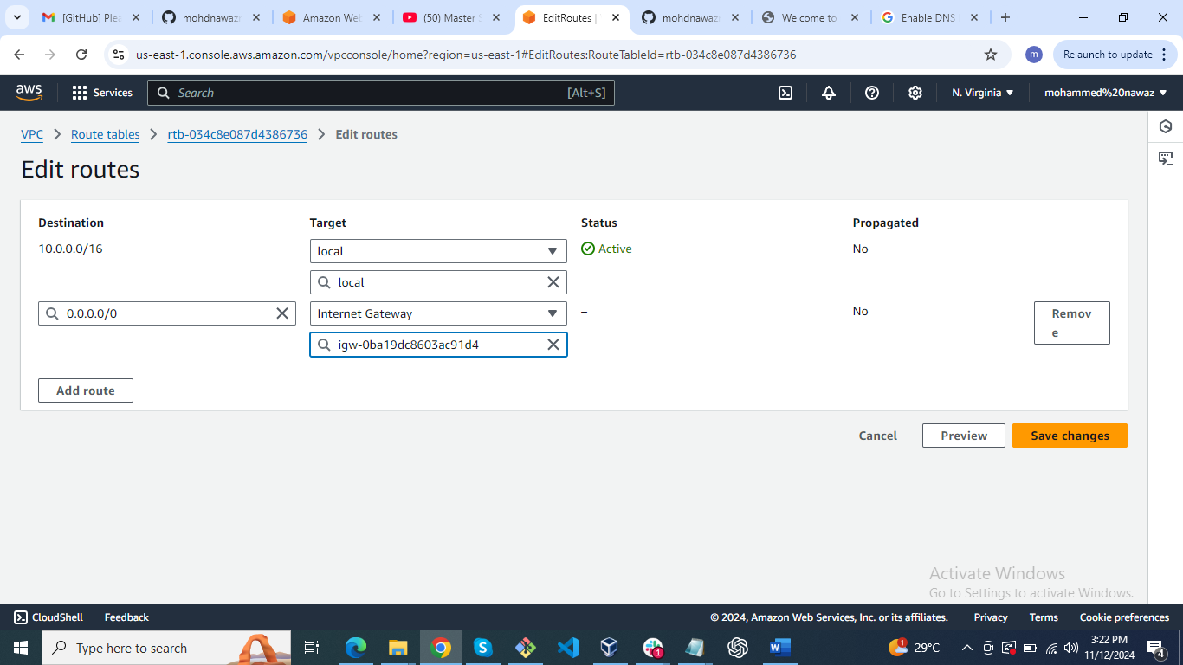

1. Create Ec2 in public subnet with t2micro and install php

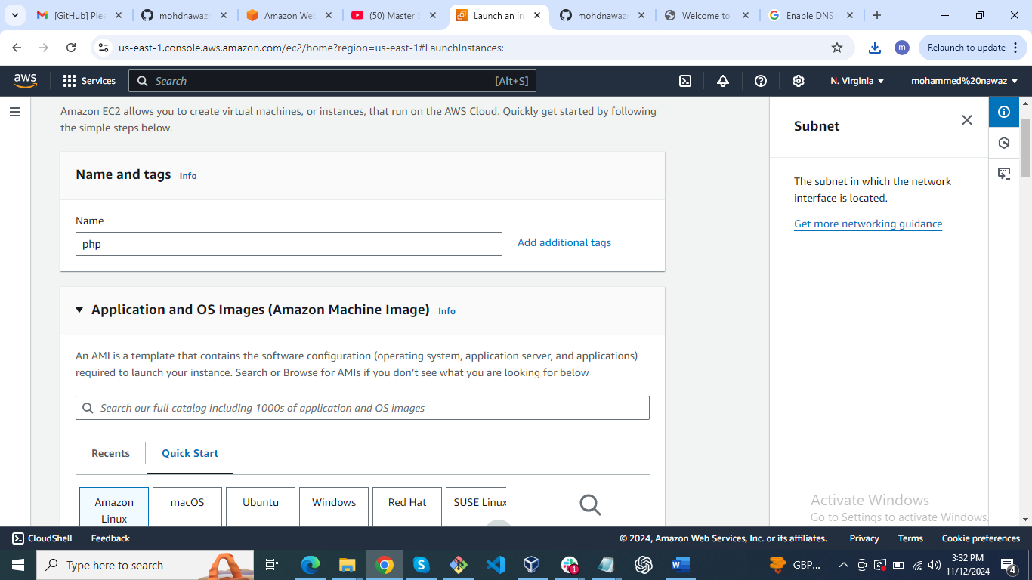

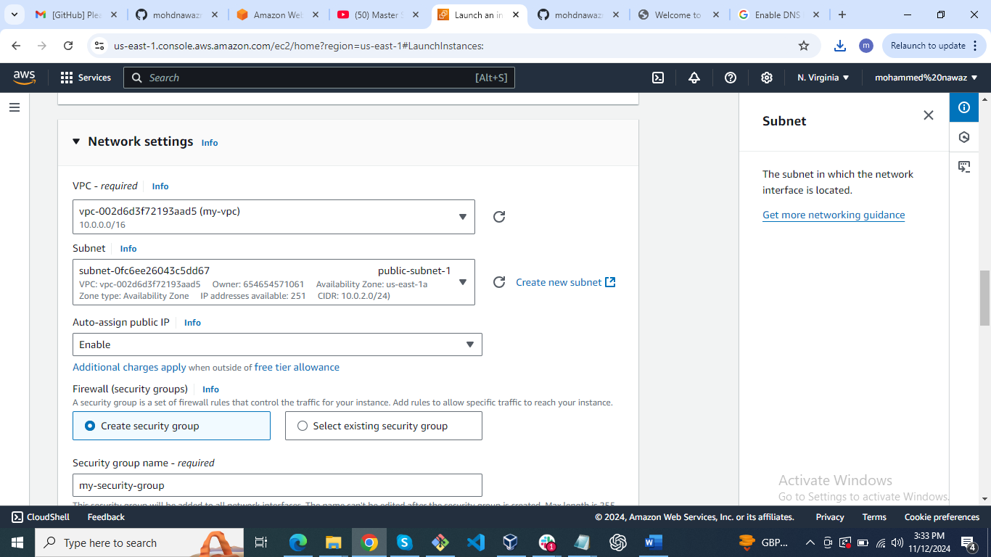

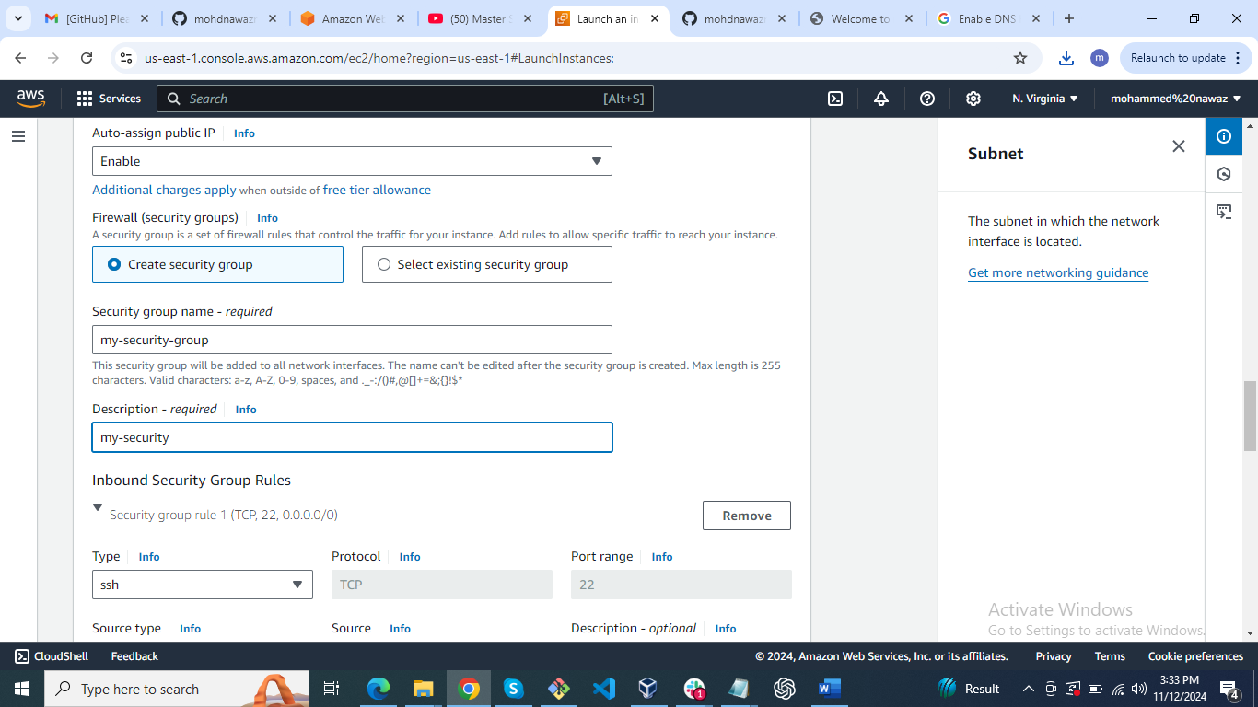

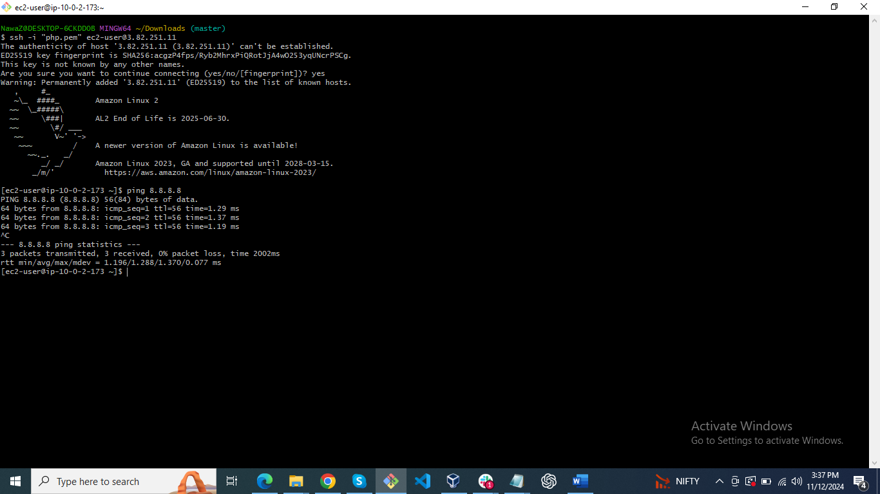

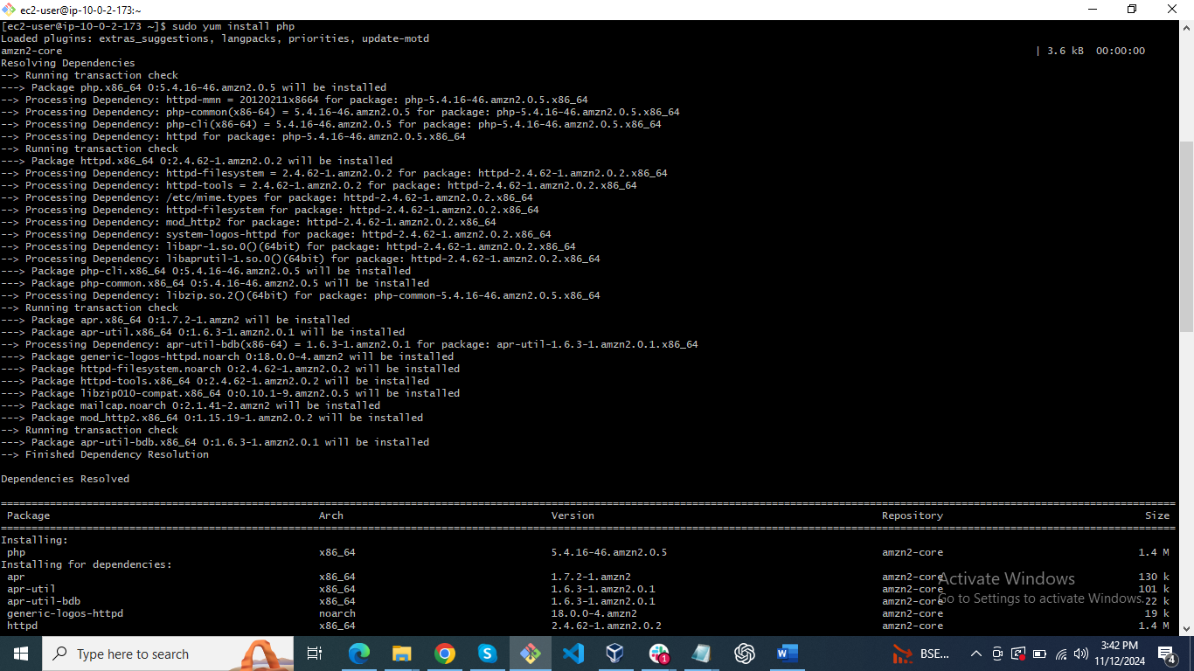

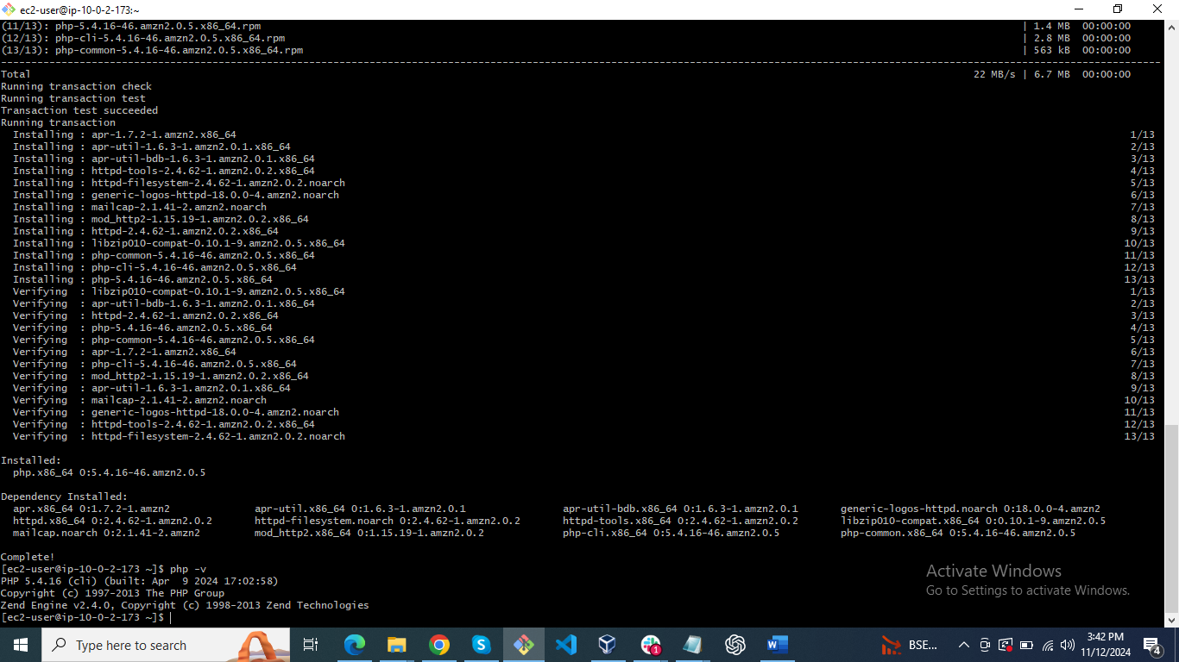

1. COnfigure Nat gateway in public subnet and connect to private Instance

Create a ec2 in private network

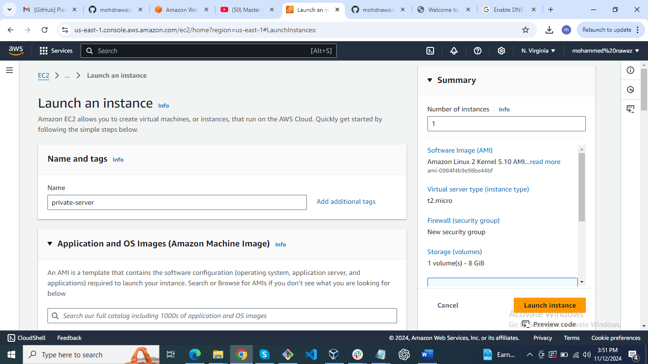

Connect through jump server

Permission chmod 600

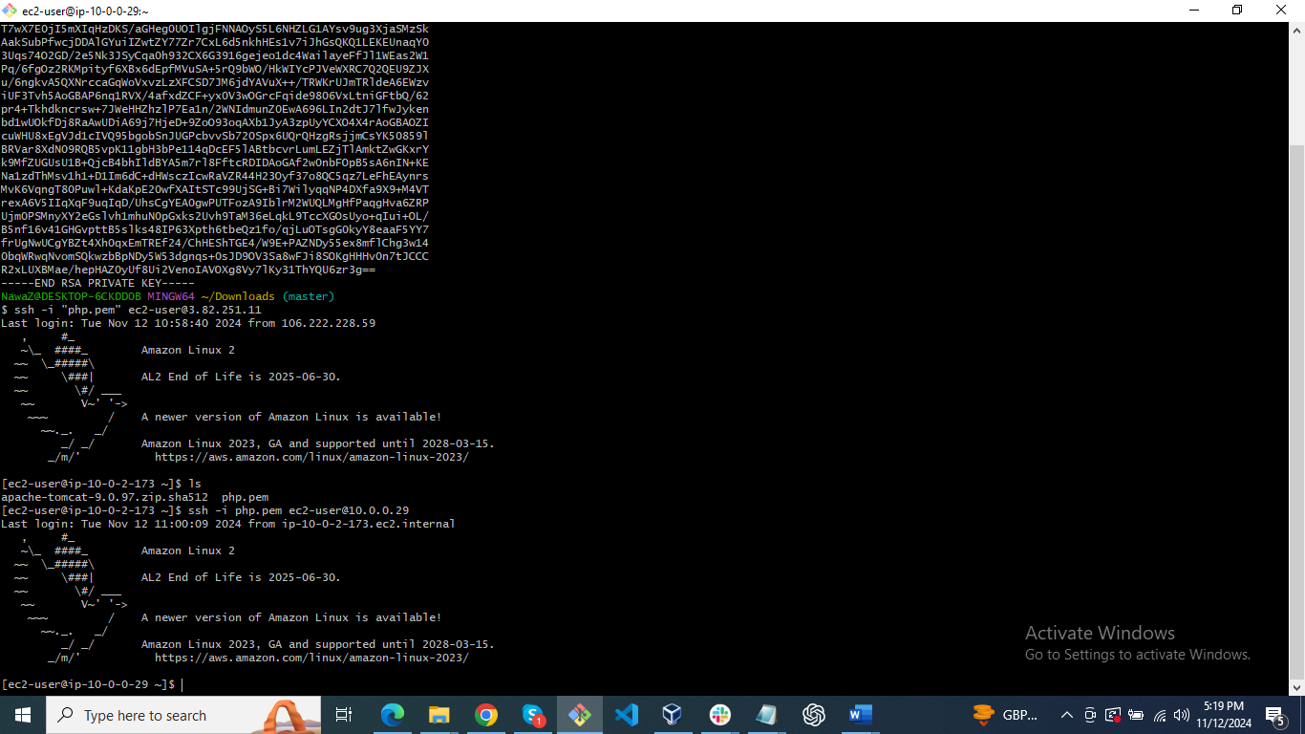

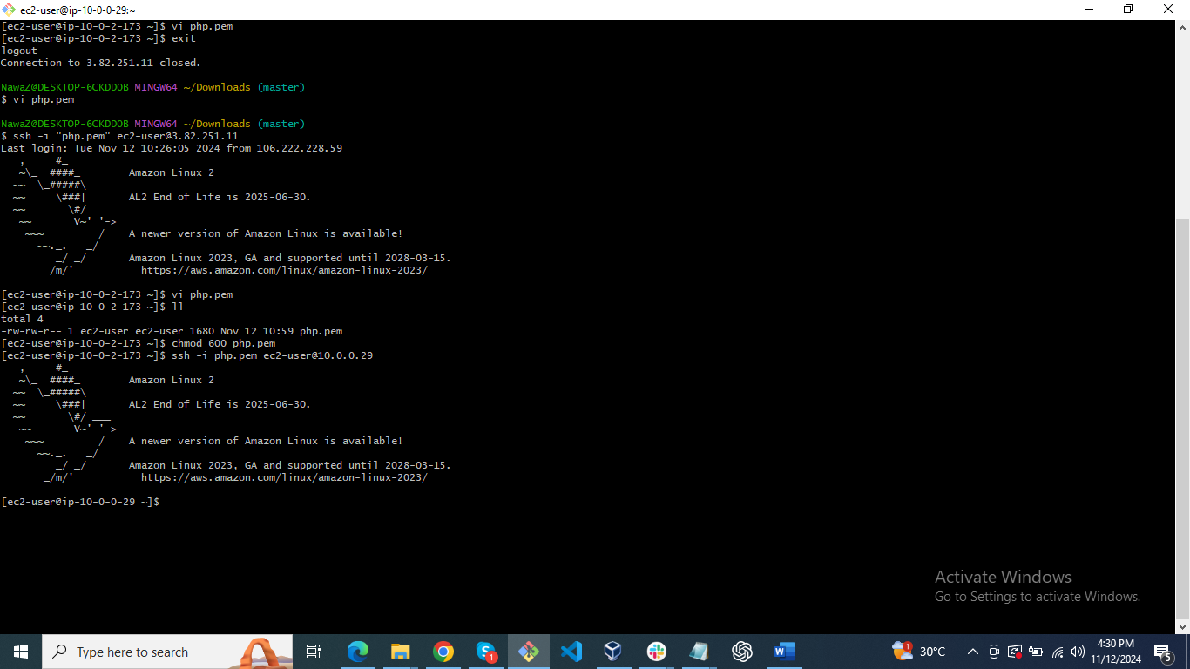

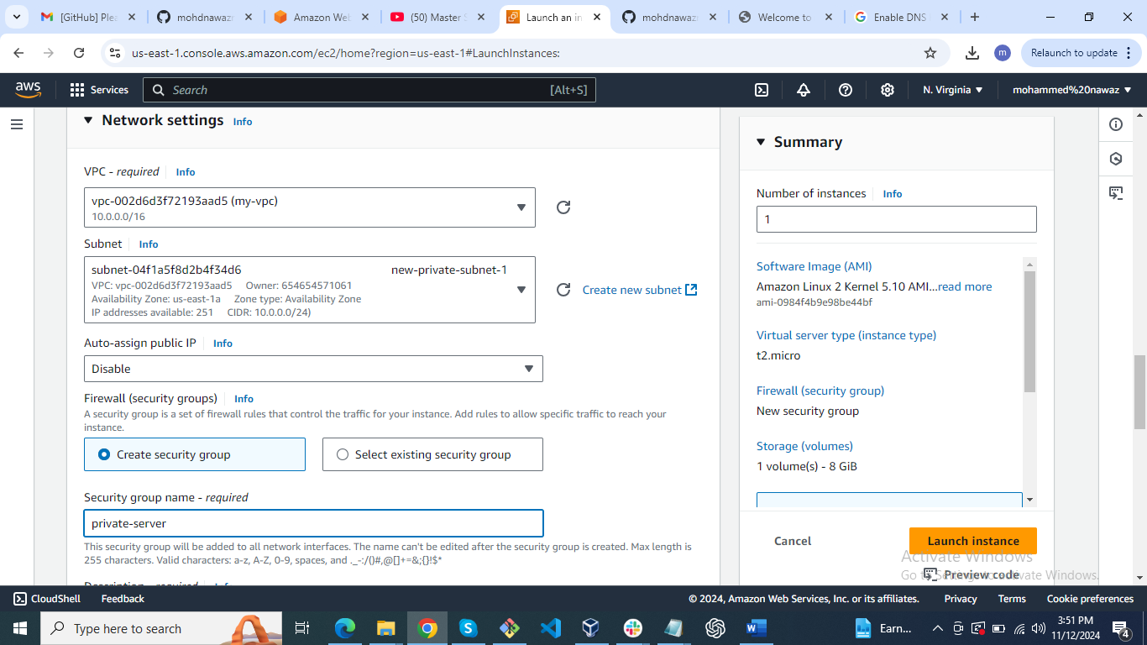

1. Install Apache Tomcat in private ec2 and deploy a sample app.

First internet on private instance

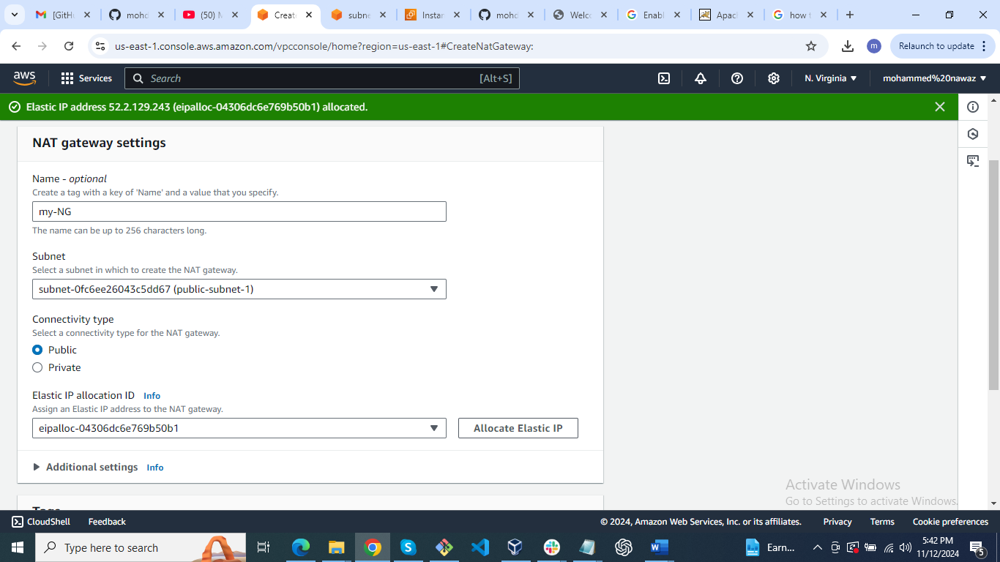

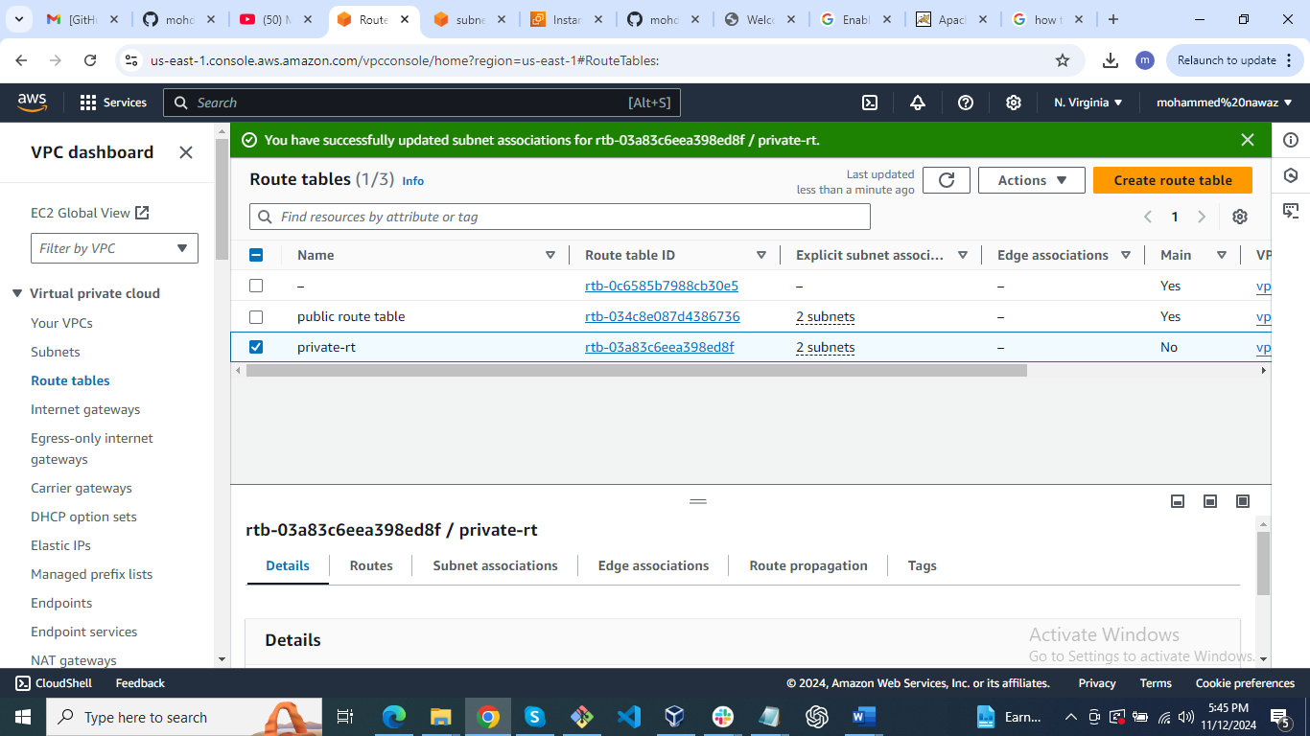

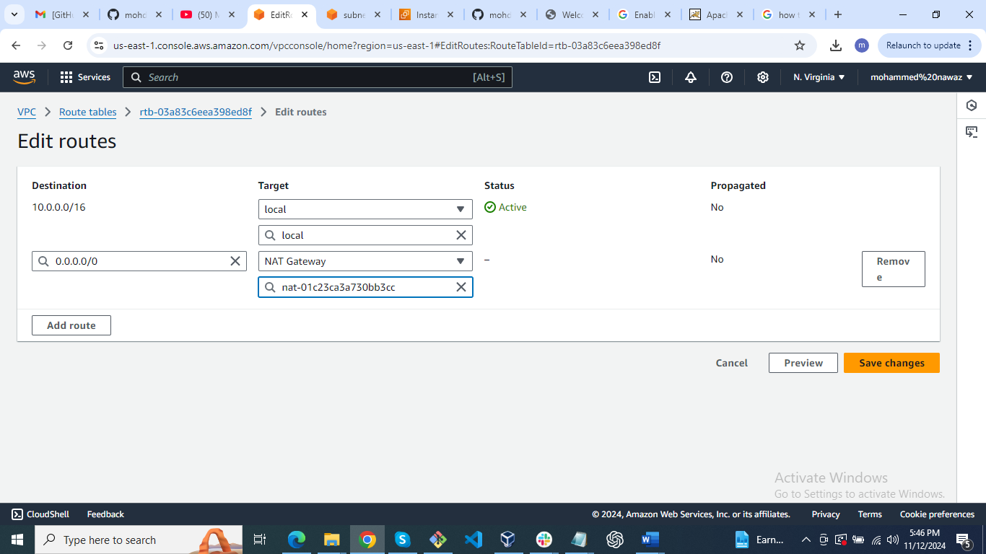

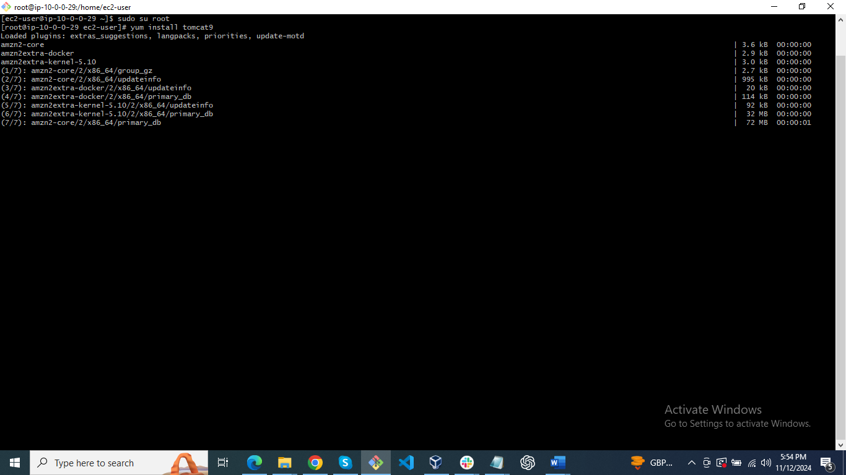



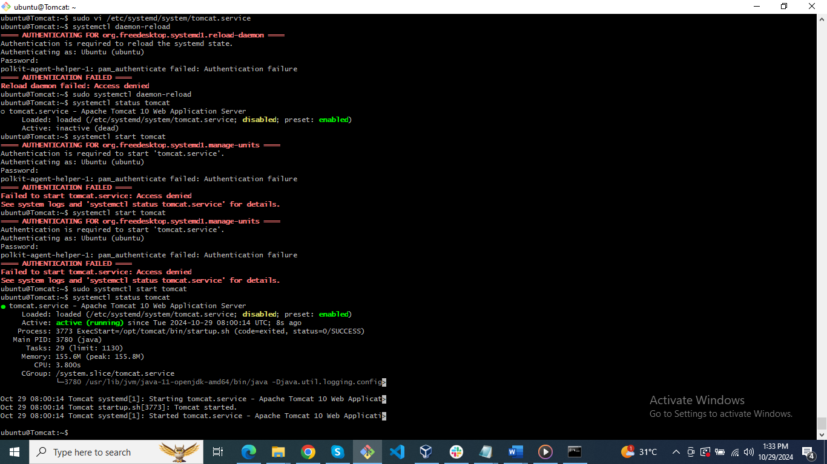

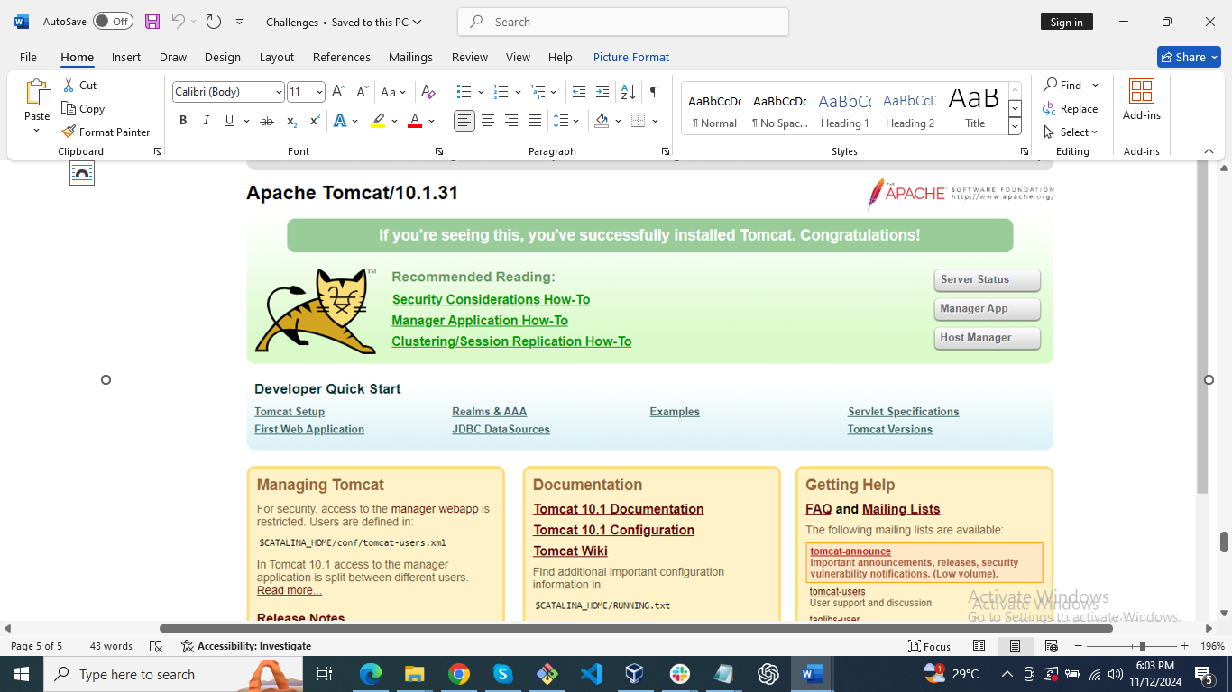

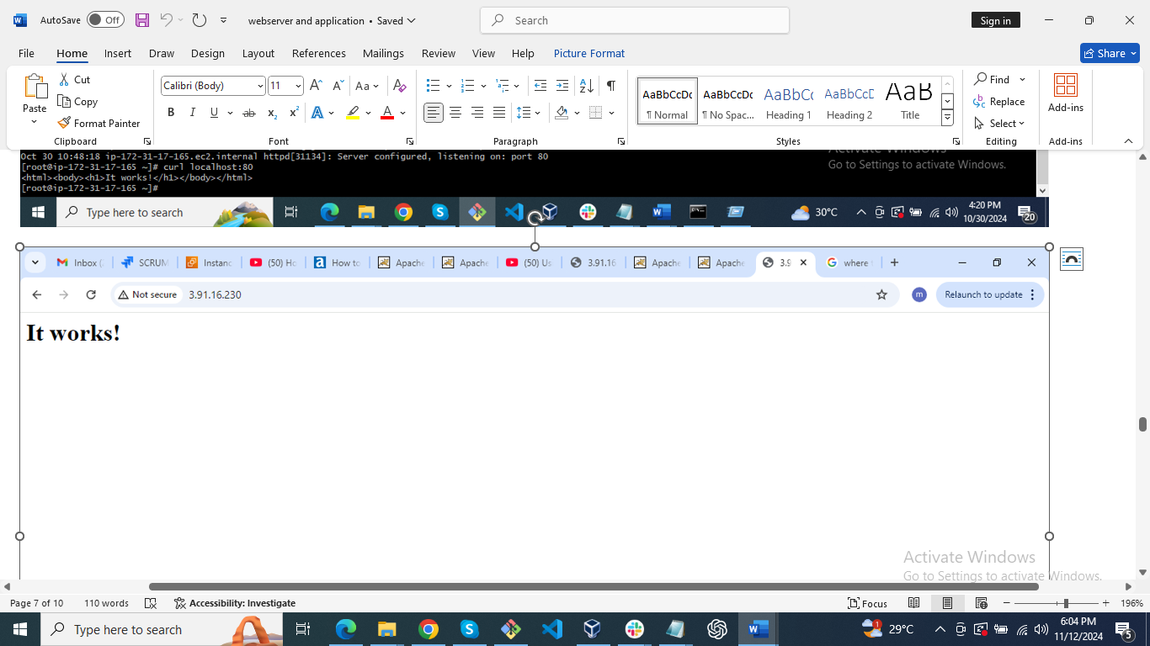

How to add start tomcat using systemctl:  
=======================================  
1) Add tomcat.service file in the below location.  
# vi /etc/systemd/system/tomcat.service

2) Add the below content  
[Unit]  
Description=Tomcat - instance %i  
After=syslog.target network.target[Service]  
Type=forkingUser=root  
Group=rootExecStart=/opt/apache-tomcat-9.0.78/bin/startup.sh    #check the path of startup.sh  
ExecStop=/opt/apache-tomcat-9.0.78/bin/shutdown.sh    #check the path of shutdown.shRestartSec=10  
Restart=always

3)Restart Daemon  
# systemctl daemon-reload

4) Start tomcat using systemctl.  
# systemctl start tomcat

1. COnfigure VPC flow logs and store the logs in s3 and cloudwatch.

